1. Consider an IP packet with a length of 4,500 bytes that includes a 20-byte IPv4 header and 40-byte TCP header. The packet is forwarded to an IPv4 router that supports a Maximum Transmission Unit (MTU) of 600 bytes. Assume that the length of the IP header in all the outgoing fragments of this packet is 20 bytes. Assume that the fragmentation offset value stored in the first fragment is 0. The fragmentation offset value stored in the third fragment is
2. An IP router with a Maximum Transmission Unit (MTU) of 1500 bytes has received an IP packet of size 4404 bytes with an IP header of length 20 bytes. The values of the relevant fields in the header of the third IP fragment generated by the router for this packet are
3. What is the subnetwork number of a host with an IP address of 172.32.66.0/21?
4. Host A sends a UDP datagram containing 8880 bytes of user data to host B over an Ethernet LAN. Ethernet frames may carry data up to 1500 bytes (i.e. MTU = 1500 bytes). Size of UDP header is 8 bytes and size of IP header is 20 bytes. There is no option field in IP header. How may total number of IP fragments will be transmitted and what will be the contents of offset field in the last fragment?
5. Consider the network having IP address 210.10.20.0 and the network is divided into two subnets, then find out the subnet id, range and number of valid addresses.
6. Consider user have a large network having IP address 205.10.40.0. However, user wants to do subnetting and divide this network into 3 subnets, such that first contains 126 hosts and other two contains 62 hosts each, then find out the subnet id, range and number of valid addresses.
7. Consider a network with 6 routers R1 to R6 connected with links having weights as shown in the following diagram.

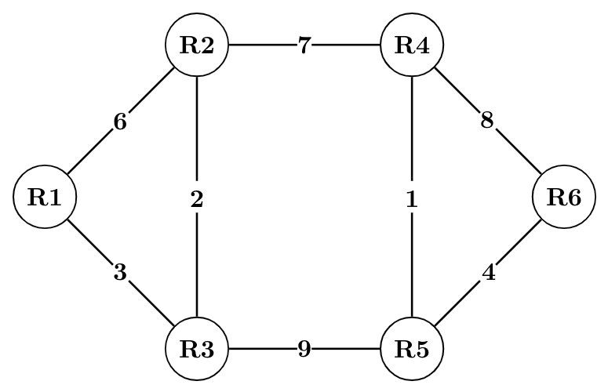

All the routers use the distance vector based routing algorithm to update their routing tables. Each router starts with its routing table initialized to contain an entry for each neighbour with the weight of the respective connecting link.

1. After all the routing tables stabilize, how many links in the network will never be used for carrying any data?
2. Suppose the weights of all unused links in the previous question are changed to 2 and the distance vector algorithm is used again until all routing tables stabilize. How many links will now remain unused?
3. Consider a network with five nodes, N1 to N5, as shown below.

The network uses a Distance Vector Routing protocol. Once the routes have stabilized, the distance vectors at different nodes are as following.

N1: (0, 1, 7, 8, 4)  
N2: (1, 0, 6, 7, 3)  
N3: (7, 6, 0, 2, 6)  
N4: (8, 7, 2, 0, 4)  
N5: (4, 3, 6, 4, 0)

Each distance vector is the distance of the best known path at that instance to nodes, N1 to N5, where the distance to itself is 0. Also, all links are symmetric and the cost is identical in both directions. In each round, all nodes exchange their distance vectors with their respective neighbours. Then all nodes update their distance vectors. In between two rounds, any change in cost of a link will cause the two incident nodes to change only that entry in their distance vectors.

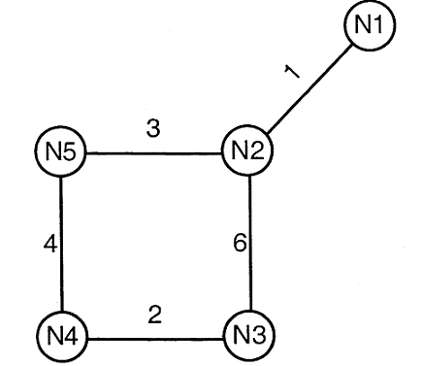

1. The cost of link N2−N3 reduces to 2 (in both directions). After the next round of updates, what will be the new distance vector at node, N3?
2. Consider the same data as given in previous question. After the update in the previous question, the link N1-N2 goes down. N2 will reflect this change immediately in its distance vector as cost, infinite. After the NEXT ROUND of update, what will be cost to N1 in the distance vector of N3?
3. A company has a class C network address of 204.204.204.0. It wishes to have three subnets, one with 100 hosts and two with 50 hosts each. Which one of the following answers represents a feasible set of subnet address/subnet mask pairs?
4. An Internet Service Provider (ISP) has the following chunk of CIDR-based IP addresses available with it: 245.248.128.0/20. The ISP wants to give half of this chunk of addresses to Organization A, and a quarter to Organization B, while retaining the remaining with itself. Which of the following is a valid allocation of addresses to A and B?
5. An organization has a class B network and wishes to form subnets for 64 departments. The subnet mask would be
6. Let the size of congestion window of a TCP connection be 32 KB when a timeout occurs. The round-trip time of the connection is 100 msec and the maximum segments size used is 2 KB. The time taken (in msec) by the TCP connection to get back to 32 KB congestion window is (Solved)
7. Consider an instance of TCP’s Additive Increase Multiplicative Decrease (AIMD) algorithm where the window size at the start of the slow start phase is 2 MSS and the threshold at the start of the first transmission is 8 MSS. Assume that a timeout occurs during the fifth transmission. Find the congestion window size at the end of the tenth transmission.